**Prayat Pongdam (1934 - Present)**

Prayat Pongdam, a National Artist from the year 1998, is a Thai printmaker. Beginning his studies in painting under the tutelage of Prof. Silpa Bhirasri, Prayat continued his education at Academia Di Belle Arti Di Roma, Italy, in 1961. After he returned to Thailand, he regularly created paintings and prints, being among the first group of Thai artists to introduce printmaking techniques to the public. He was declared an artist of distinction for his printmaking in 1981 as well as being awarded the title ‘Academico Onorario Classe Incisione’ from the Italian government via L’Accademia Florentina delle Arte del Disegno . His artworks explored ideas of nature, ways of life, and the Thai rural spirit through simple human and animal symbols that expressed feelings of warmth, affection, and love. He intentionally depicts landscapes of temples, churches, vihara, heritage sites, local villages, fields of rice, gardens, and forests as the background to his works. His composition is usually symmetrical reflecting the balance of life styles and peaceful feelings. All of these are harmonised within the unique character of his woodcut techniques. Using line, color and composition, Prayat blends plainness, purity and sincerity with nature, religion and the folk culture of rural society.

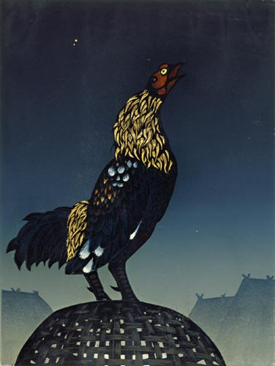

Prayat Pongdam, *The Morning*, 1981, woodcut, 60 x 80 cm, Collection of Experty Holding Co., Ltd.

Prayat is known for his use of animal figures, which he places together as if they are part of one family. Most of the animals in his artworks, including horses, cats, birds, hens, geckos, bats, and owls, relate to a rural Thai way of life. These characters display a wide range of characteristics, such as happiness, enjoyment, and horror, as they move or gaze at the viewer. In his later period, Prayat preferred to convey upon these animals human characteristics and place them in the relationships of a warm family. Most of his artworks are set within the atmosphere of dawn, evening and twilight. Using rollers with various soft and dark colors, Prayat creates an atmosphere of soft sunlight on a dark sky that can reflect the mysterious feeling and attraction of this time.

The animal figures in his prints also frequently reflect the peace and warmth of family, including this mutual sympathy as symbolic of Thai tradition. In addition, Prayat always brings some symbols of Thai traditional identity into his work, including folk costumes, architectural structures, Thai traditional patterns, daily equipment, water jars, and northern weaving clothes. He also uses golden leaves collage onto his printmaking to reflect the character of Eastern art.

**References and Further Reading:**

Hi - Class Magazine. (1995). *16 Thai Contemporary Artists.* Bangkok: Hi - Class Magazine.

Prayat Phongdam. (2011). *Exhibition Catalogue of Prayat Phongdam Retrospective Exhibition*. Bangkok: Faculty of Painting Sculpture and Graphic Arts, Silpakorn University.

Vichoke Mukdamanee. (2003). *6 Decades of Thai Contemporary Art*. Bangkok: Silpakorn University Art Centre